Machine Description | The challenge is to enumerate exposed services, extract weak credentials, escalate privileges on the host, and use those credentials to gain full control and pivot into the simulated network.
Target IP | 10.17.22.129
Vulnerability Name | Weak password and privilege escalation vulnerability.
CVSS Score and Severity | 9.8 Critical
Attack Vector | CVSS:3.0/AV:N/AC:L/PR:N/UI:N/S:U/C:H/I:H/A:H
Proof Of Concpet | STEP 1 – Host discovery using Netdiscover Tool  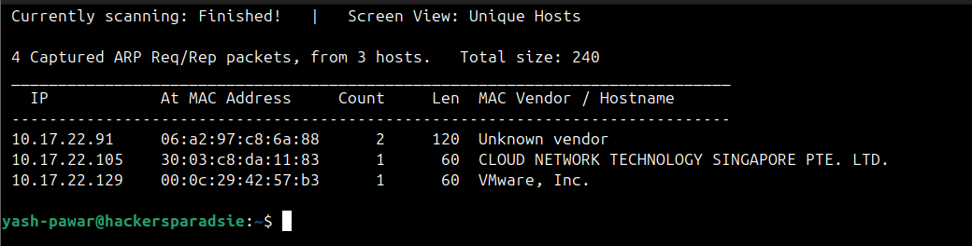  STEP 2 – We can store IP address in Environment Variable so we can call it whenever we need  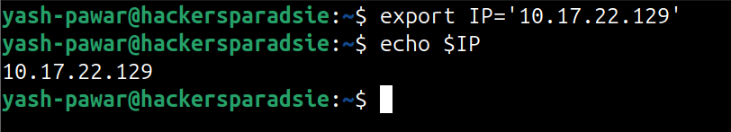  STEP 3 – Nmap Scan on the Target for looking open ports  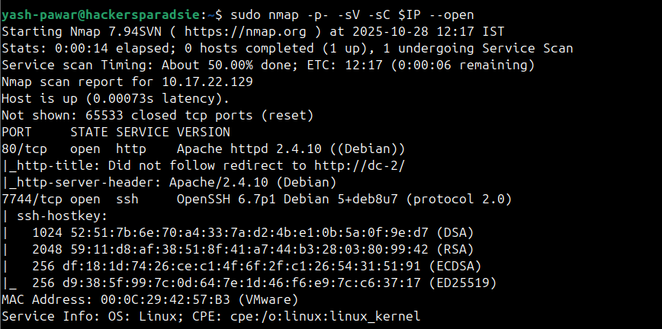  STEP 4 – We can See Target is running the 80 (HTTP) and 7744 (SSH) lets try to visit and see what on server  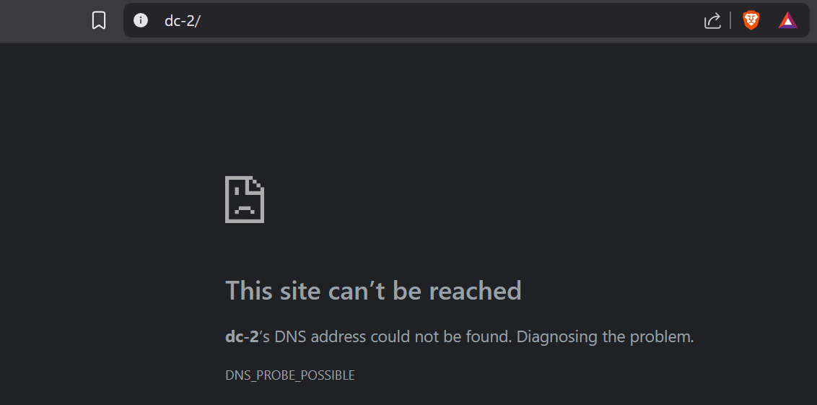  STEP 5 – It is not able to resolve the address so lets manually add records in /etc/host file for dc-2  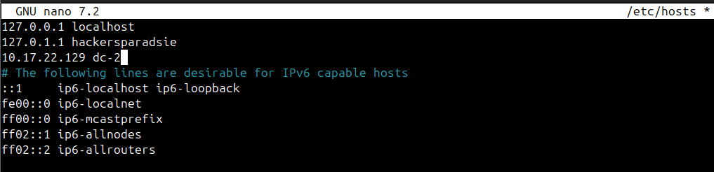  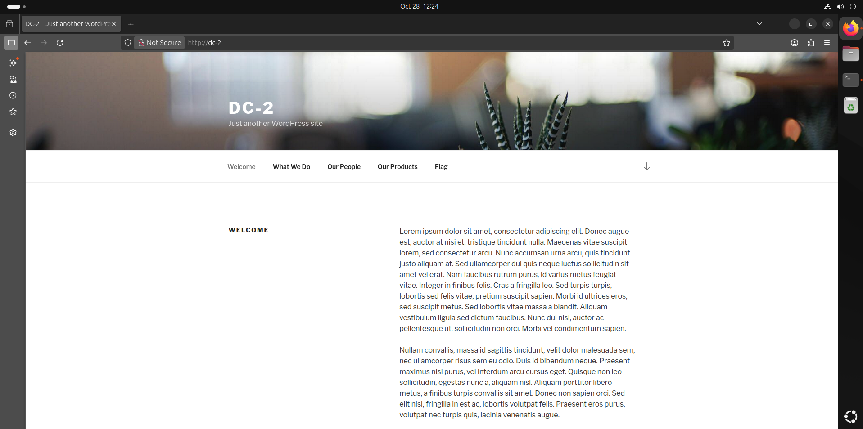  STEP 6 – Lets look for available directory available on target machine  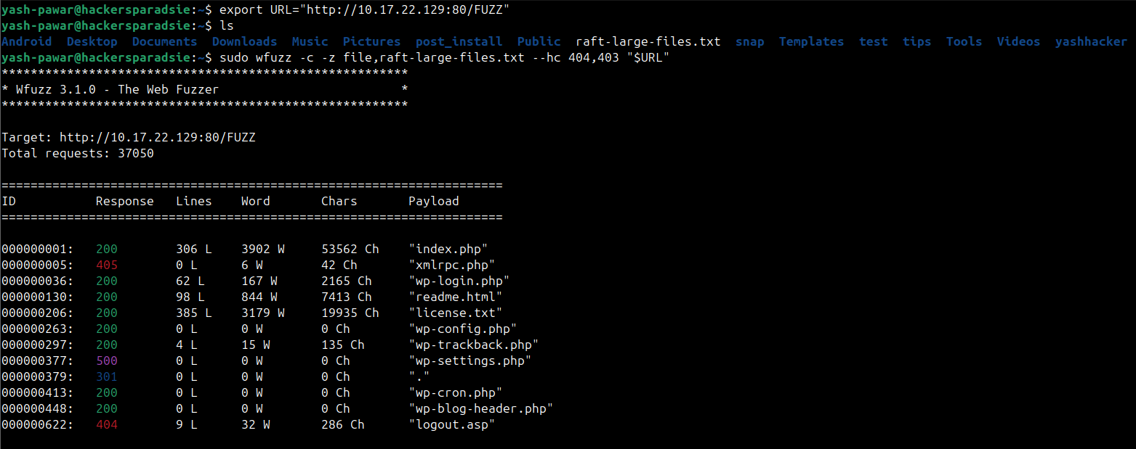  We found wp-login page and lets try to enter test cred and see the behaviour  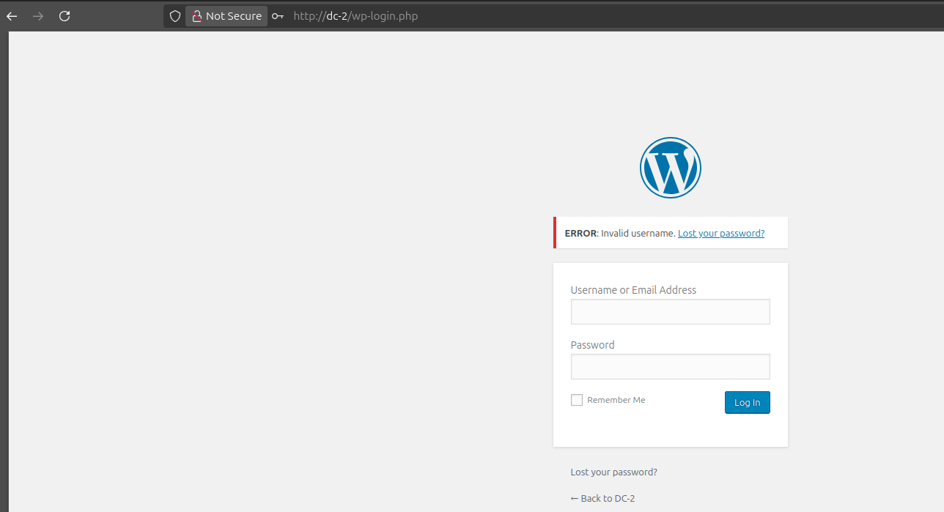  STEP 7 - We found that there is an error that says “Invaild username” so we can try to enumerate valid usernames with this kind of error  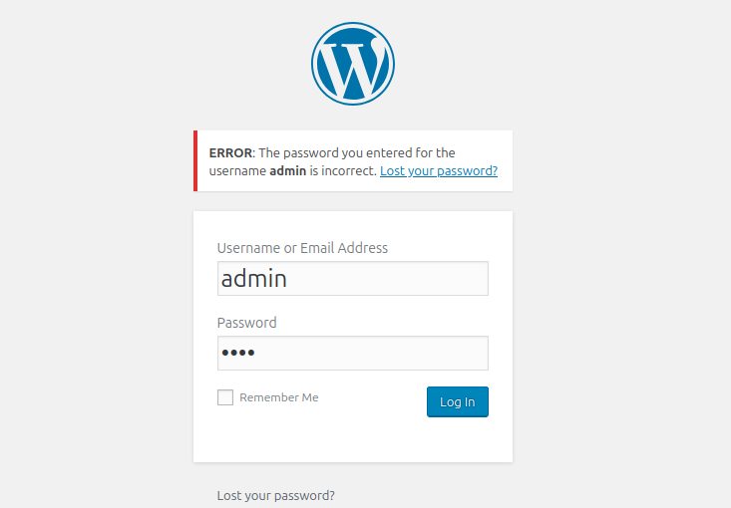  STEP 8 – Let’s Enumerate plugin’s themes and users with Wpscan because we can find valid usernames for login attacks and lists installed themes and plugins that may have known vulnerabilities  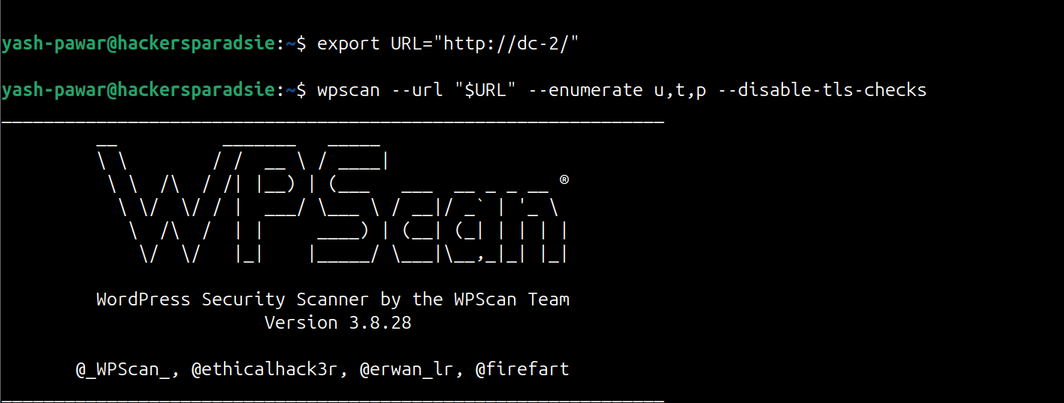  We have found some valid usernames ( admin , jerry , tom ) Save Users in Users.txt  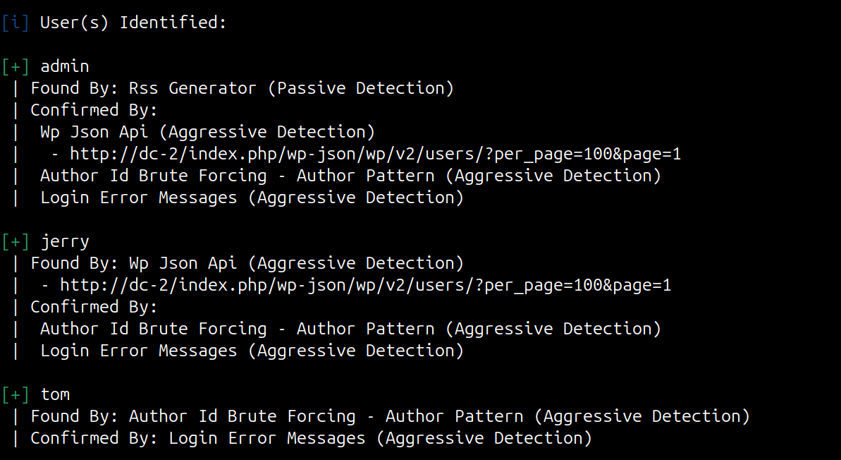  STEP 9 - Lets Create wordlist to brute force for valid credentials using CEWL tool  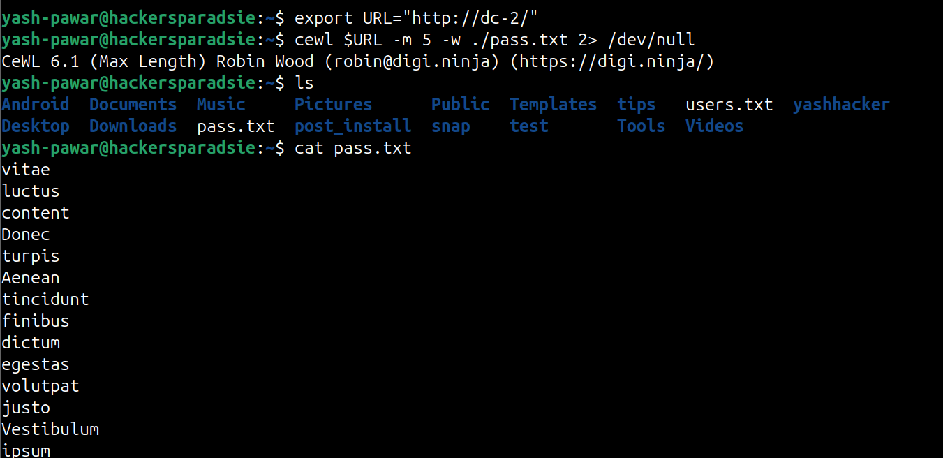  STEP 10 – Brute Force using Wpscan  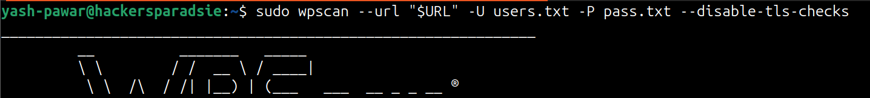  We found Some Valid credentials ( jerry : adipiscing ) ( tom : parturient )  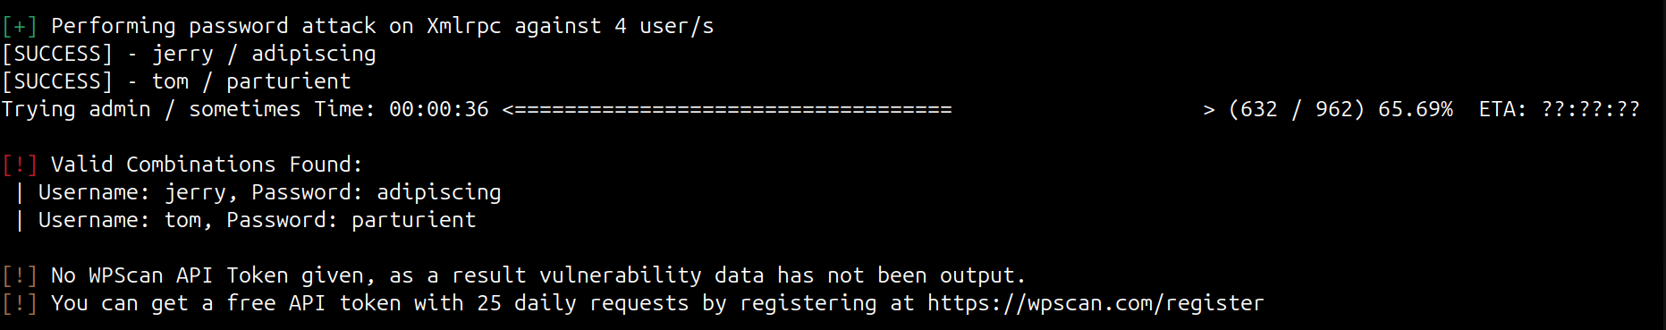  STEP 11 – Lets try to authenticate using SSH  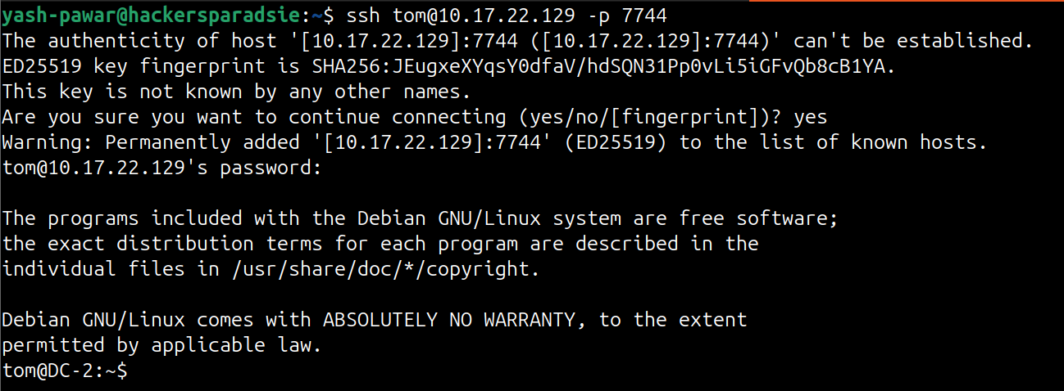  STEP 12 - We got login but we are into restricted bash. Lets get out of it  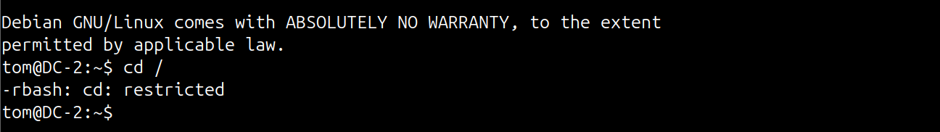  - Open “vi” editor  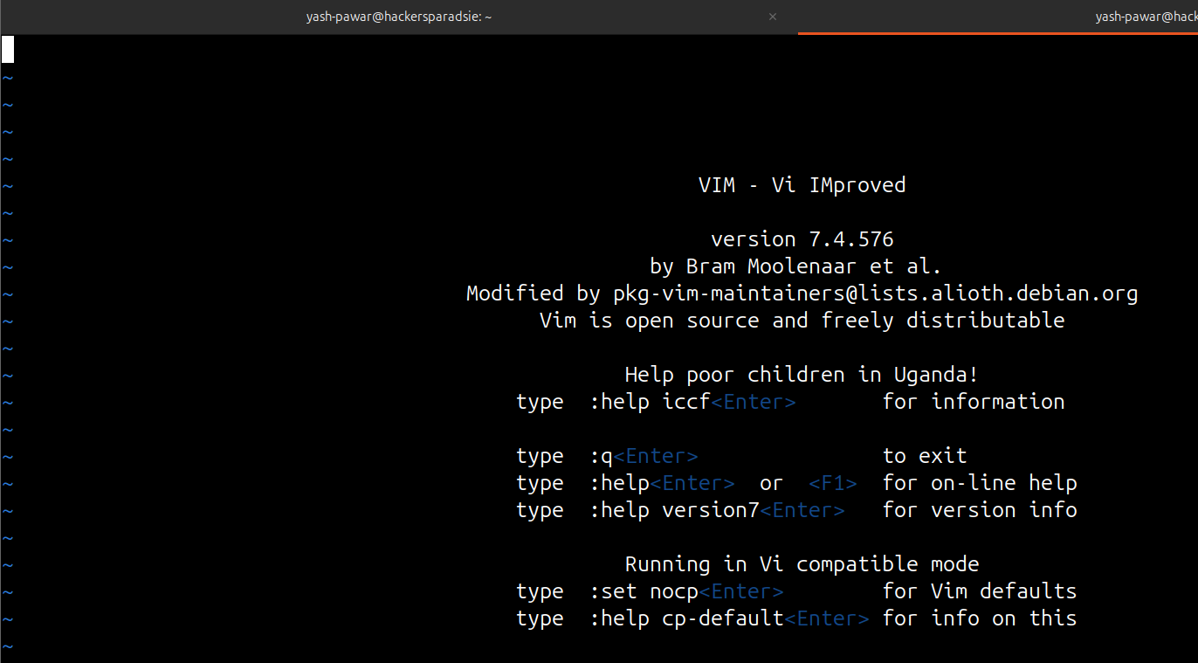  - While we are in command mode lets set variable “:set shell =/bin/bash” and hit enter.  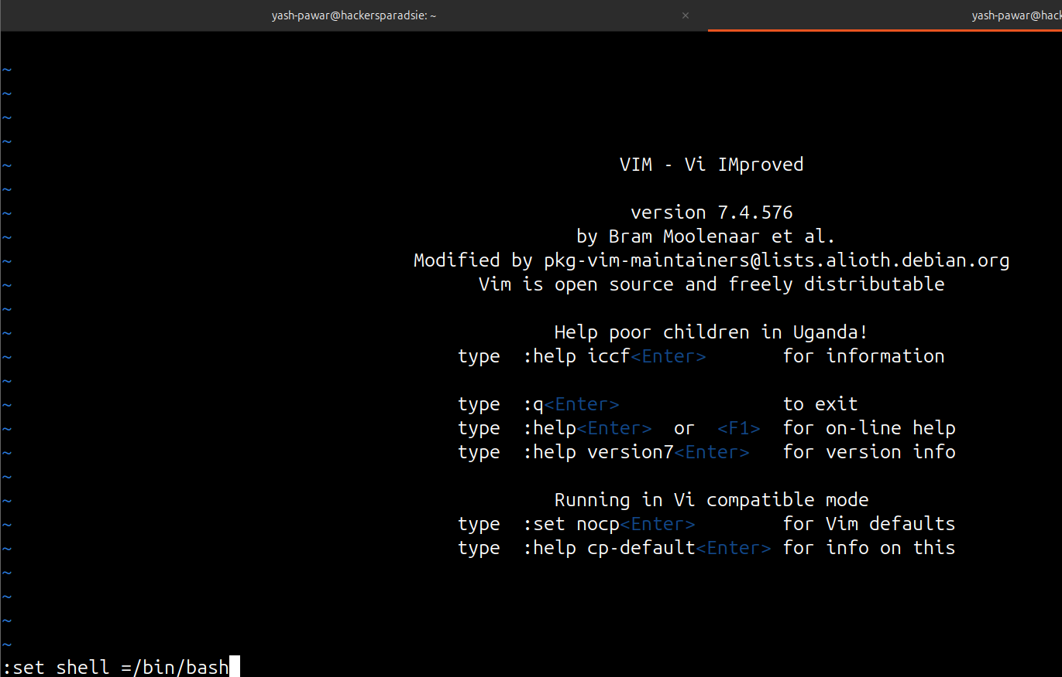  - After hitting Enter we will see that our cursor is again on top and we are still in command mode so next call “:shell” and hit enter  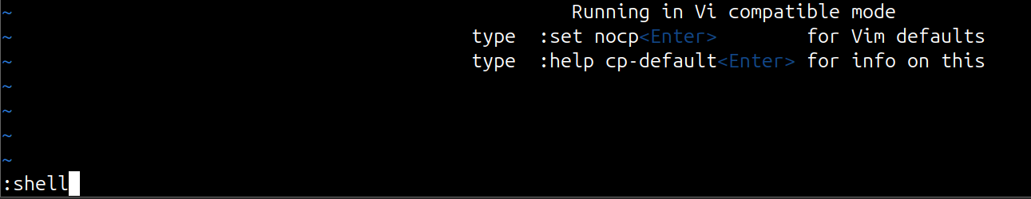  - We will be out of Vi editor and also rbash  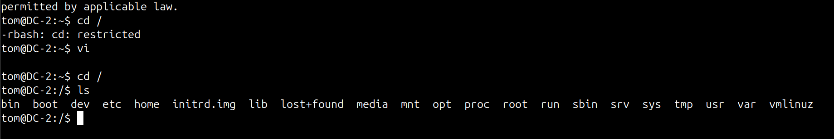  - Our current shell don’t know where to look for the binaries so we will set environment variable in PATH variable  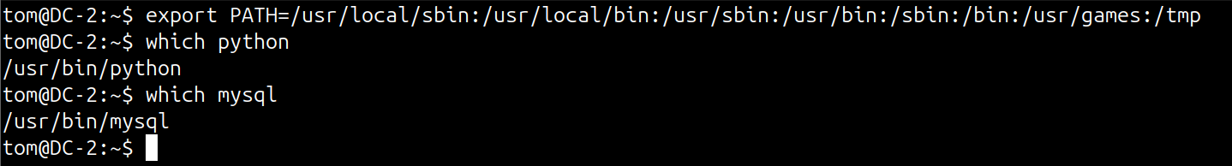  STEP 13 – Lets Enumerate and find in /var/www/html because its running Wordpress CMS  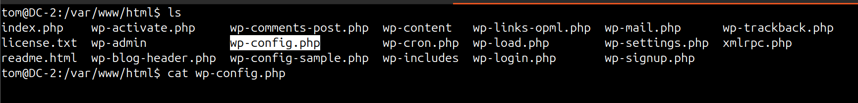  And Here we got credentials for database server (wpadmin : 4uTiLL)  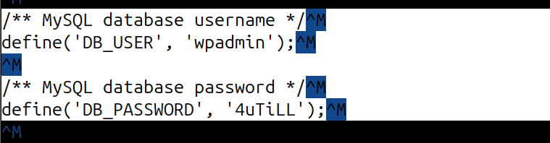  - Lets try to authenticate  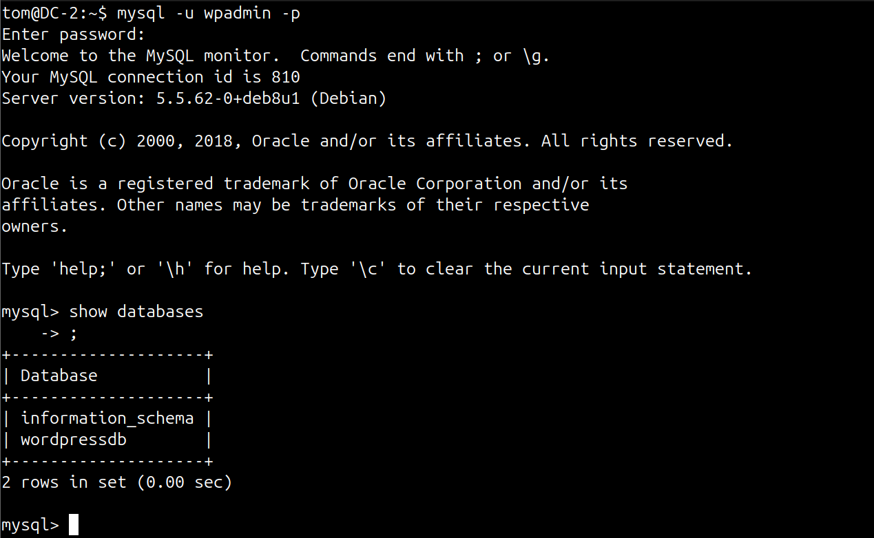  - Lets try to enumerate further here we got more hashes for users we can crack them as well but lets proceed  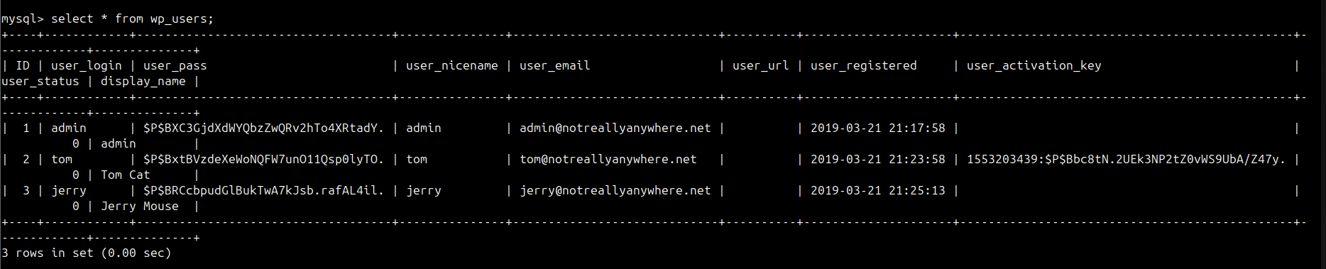  STEP 14 – Lets try to switch user to Jerry  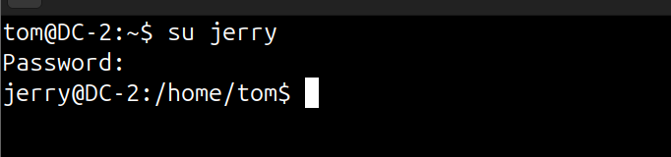  - Set Environment again so we can run commands smoothly  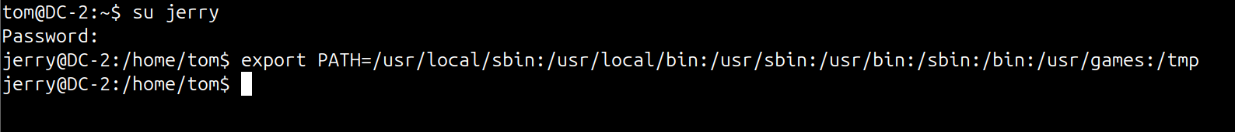  STEP 15 – Privilege Escalation to root user  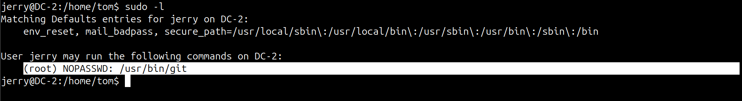  - Jerrey is able to run git command using sudo as root without password so lets try to look in GTOFBINS  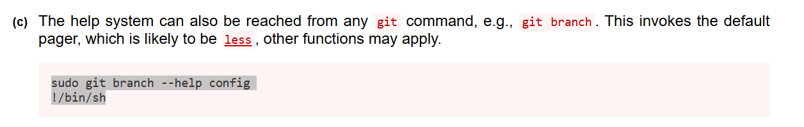  - Increase size of page and then run the command  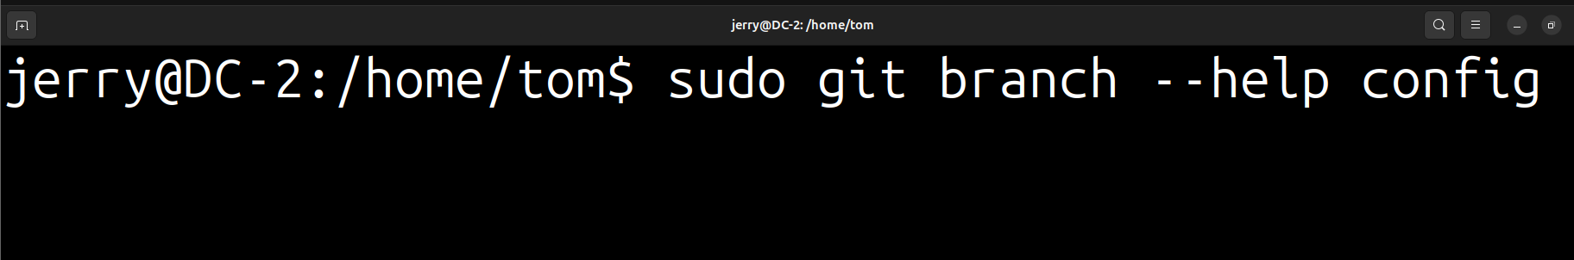  - Then insert “!/bin/dash”  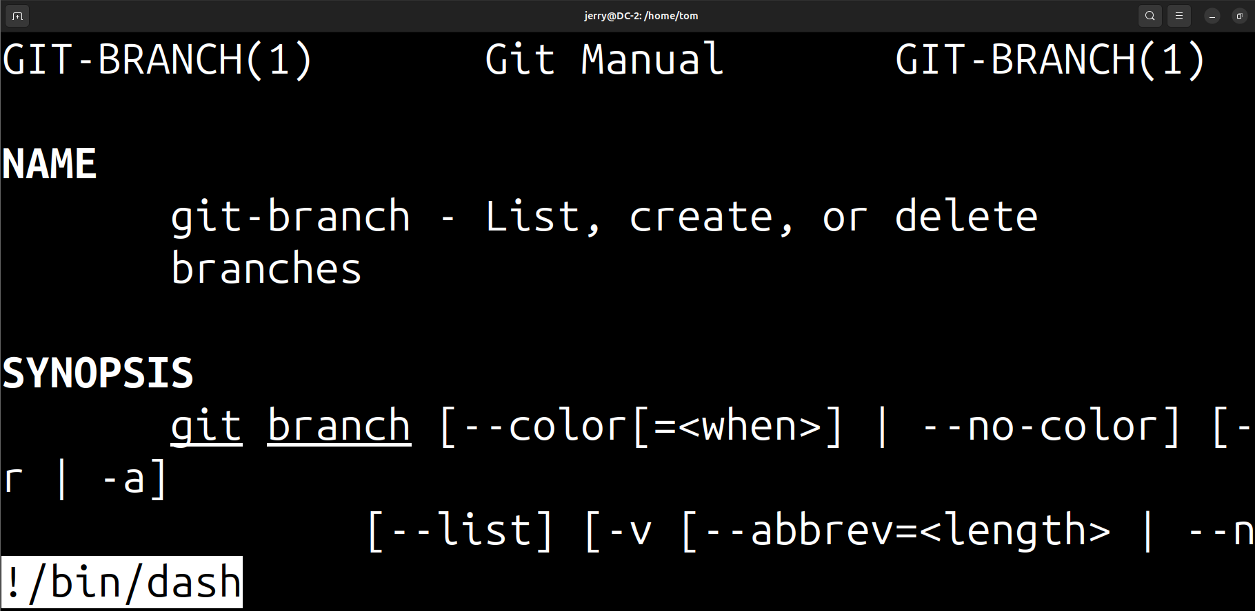  - exit and we get root access  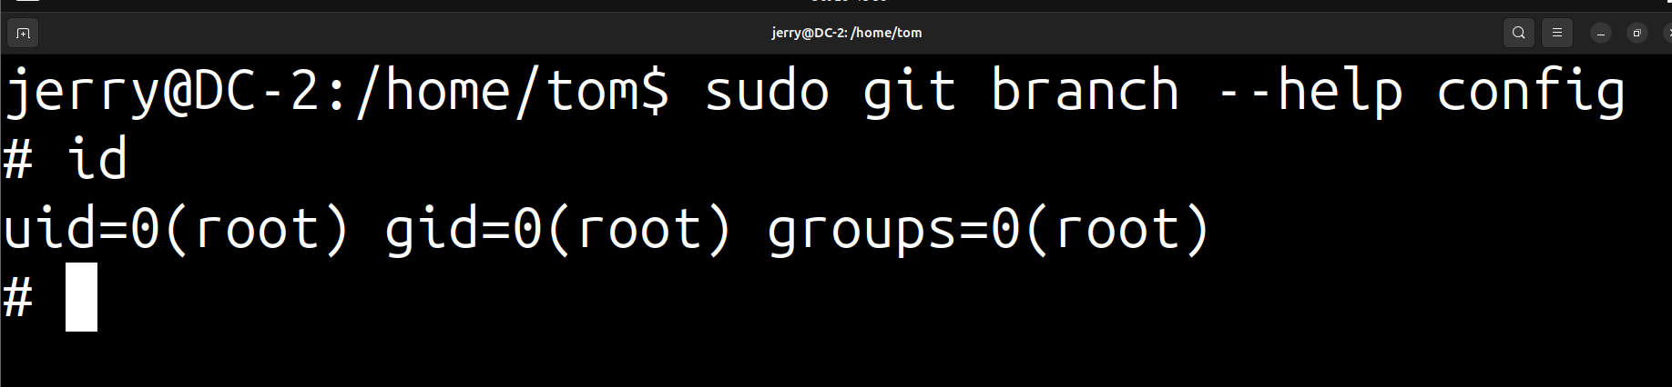  Here we got final flag in /root directory and we have solved the machine  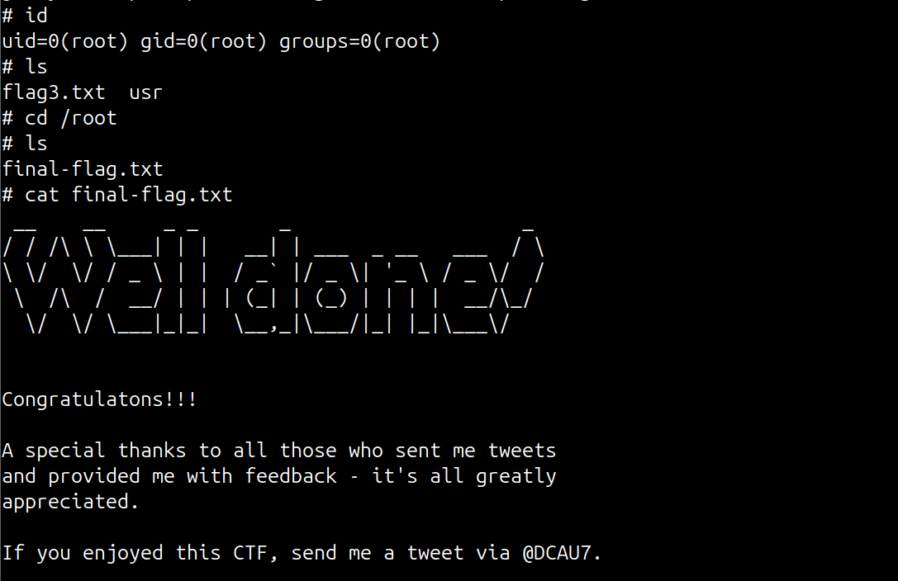  STEP 16 – Change password for users  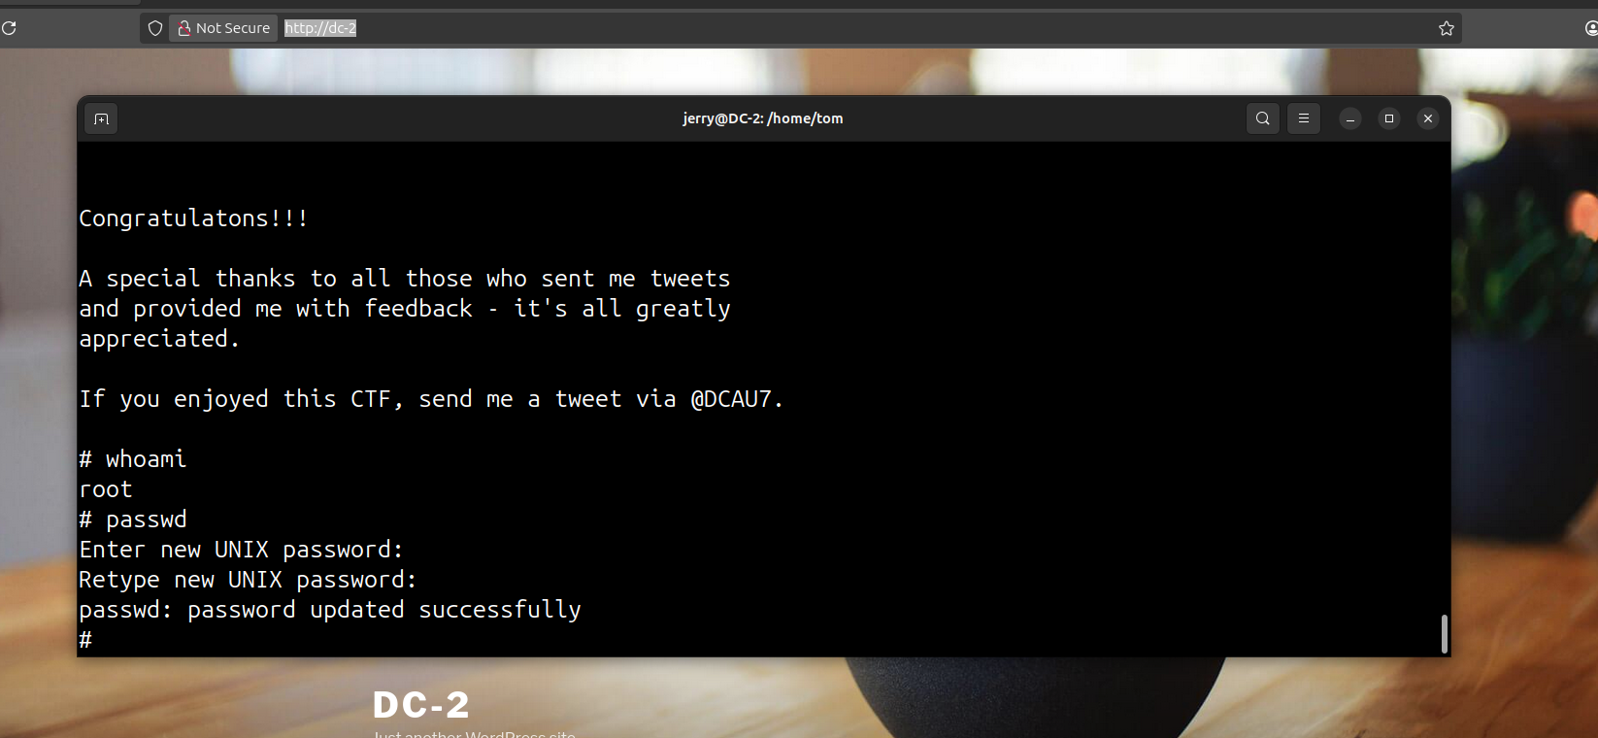
Impact | - Credential theft enables account takeover and privilege abuse.  - Local privilege escalation leads to full host compromise.  - Exposed service accounts permit lateral movement across the lab.  - Increased remediation cost and loss of confidence in the environment.
Remediations | - Rotate all weak and default passwords; enforce strong password policy.  - Remove plaintext credentials and store secrets in a secure vault.  - Harden service permissions and apply least privilege to accounts.  - Enable logging, alerting, and periodic credential and permission audits.
Reference | https://www.vulnhub.com/entry/dc-2%2C311

